Pursuant to Article 61 of the Law on the Election of Members of Parliament ('Official Gazette of RS' No. 35/2000),
Minister of Justice, whose duties in accordance with Article 3 of the Law on Labour of the Government of the Republic of Serbia and Ministries, until the formation of the Government of the Republic of Serbia after parliamentary elections in 2000 ('Official Gazette of RS' No. 38/2000), are performed by a Collegium, hereby adopts

THE INSTRUCTIONS
ON THE SHAPE AND SIZE OF THE BALLOT BOX
Article 1
These instructions specify the shape and size of the ballot box and the material it is made of.
Article 2
The ballot box shall be in the shape of a cuboid, of the following size: width 35 cm, length 50 cm and height 60 cm, with possible deviation of 30% depending on the number of voters per polling station, according to the excerpts from the electoral roll.
At its upper part a ballot box shall have along its whole length and width side a sliding lid which is grooved along its whole length, in the upper part of the ballot box.
In the middle of the moving part of the lid it shall have 20 cm long and 1 cm wide narrow slot to accept a ballot paper in an election.
On the left and right side of the sliding lid and on the main part of the ballot box, two circular holes are positioned on each side, 0,5–1 cm in diameter,3–5 cm apart from one another.
Through the circular holes on the lid and the main part of the box, a rope is pulled through, it is then tied and sealed by the polling board.
An outline drawing of the ballot box is an integral part of these instructions.
Article 3
The ballot box shall be made from transparent, hard material which ensures safety of the ballot papers and secrecy of the ballot. (acrylic glass, plastic or other similar material).
Article 4
On the day these instructions enter into force, the Instructions on the shape and size of the ballot box ("Official Gazette of the Republic of Serbia", No.37/97) shall cease to have effect.
Article 5
These Instructions shall enter into force on the day following the date of its publication in the ”Official Gazette of the Republic of Serbia”.
Number 110-00-000-93/2000
In Belgrade, 3 November 2000
Minister of Justice
Collegium
Dragan Subasic, m.p.
Sead Spahovic, m.p.
Zoran Nikolic, m.p.

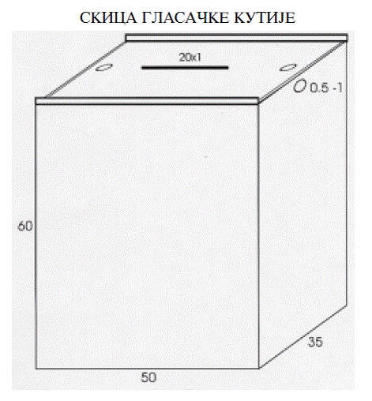

“Official Gazette of the Republic of Serbia”, No. 42/00)

